**Bellevue University**

**CIS 530-T301 – Server-Side Development, Spring 2024**

**Professor: Patrick Gold**

**Sindhu Narasimharajapura Gopal**

**Snapshot :Spring - Initializr**

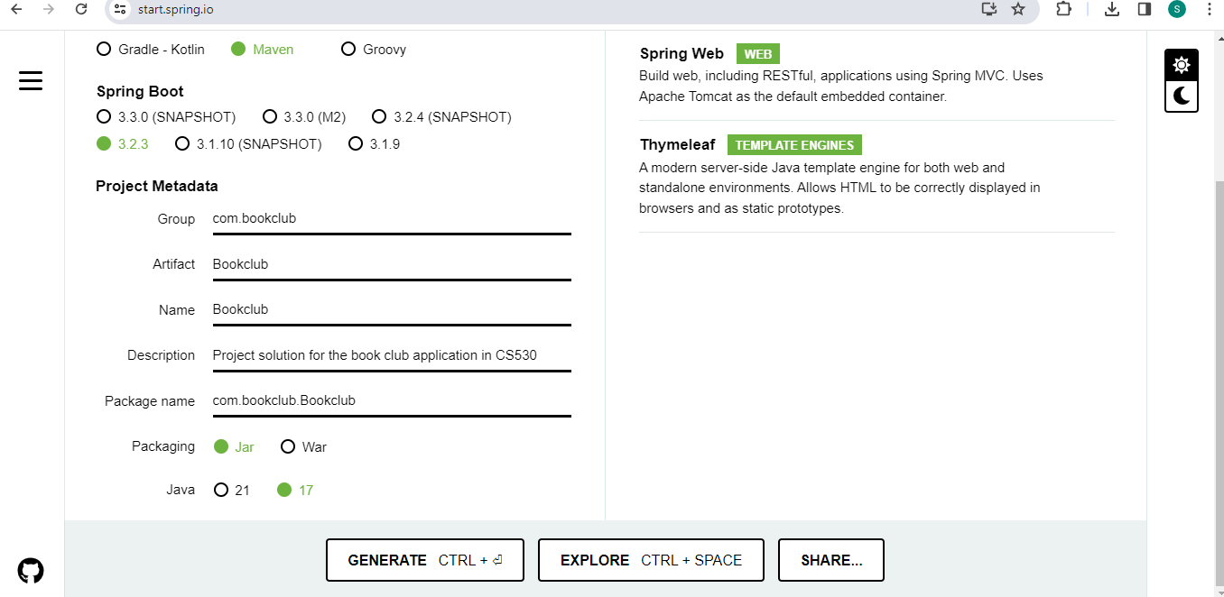

**Index.html file creation and execution**

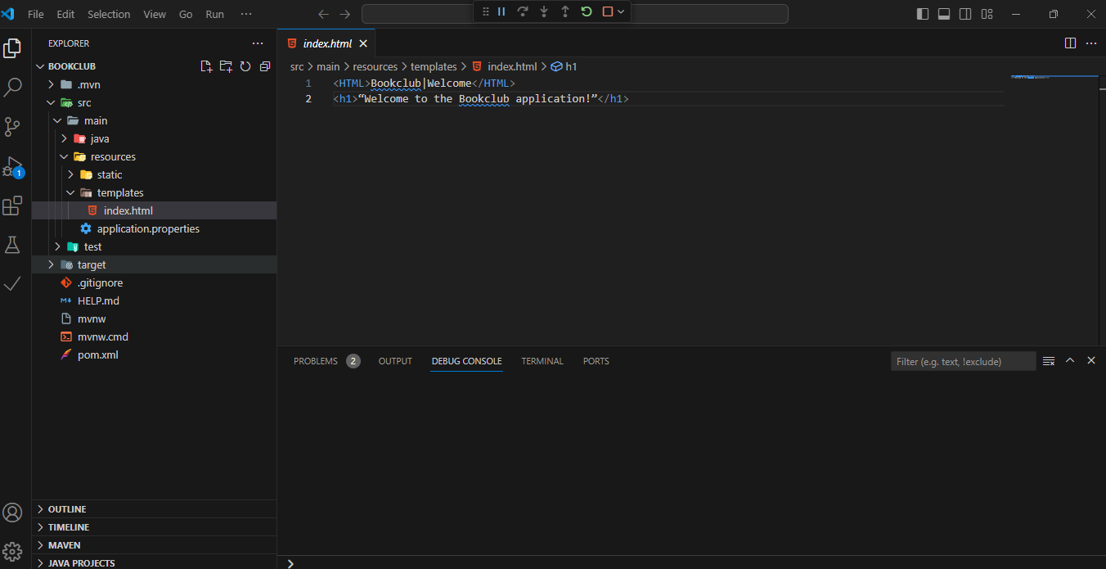

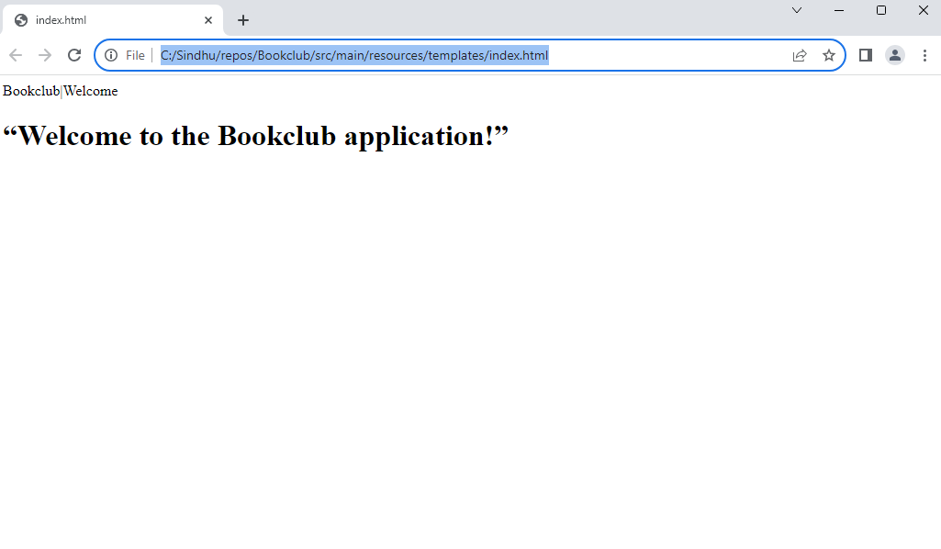

**New Repository Creation :**

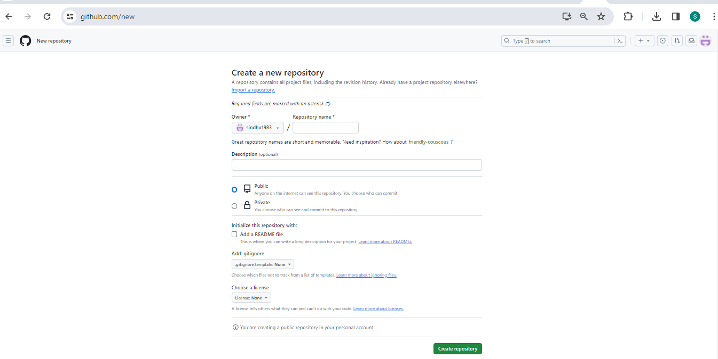

**Git Installation :**

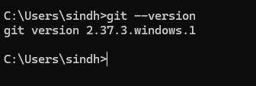

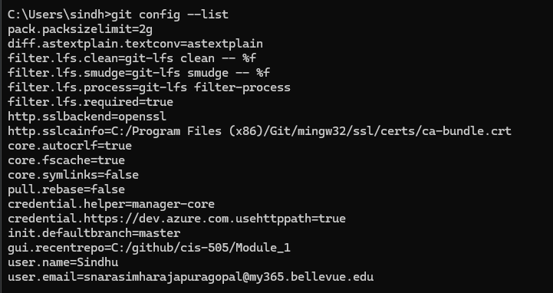

**Visual Studio Code Setup:**

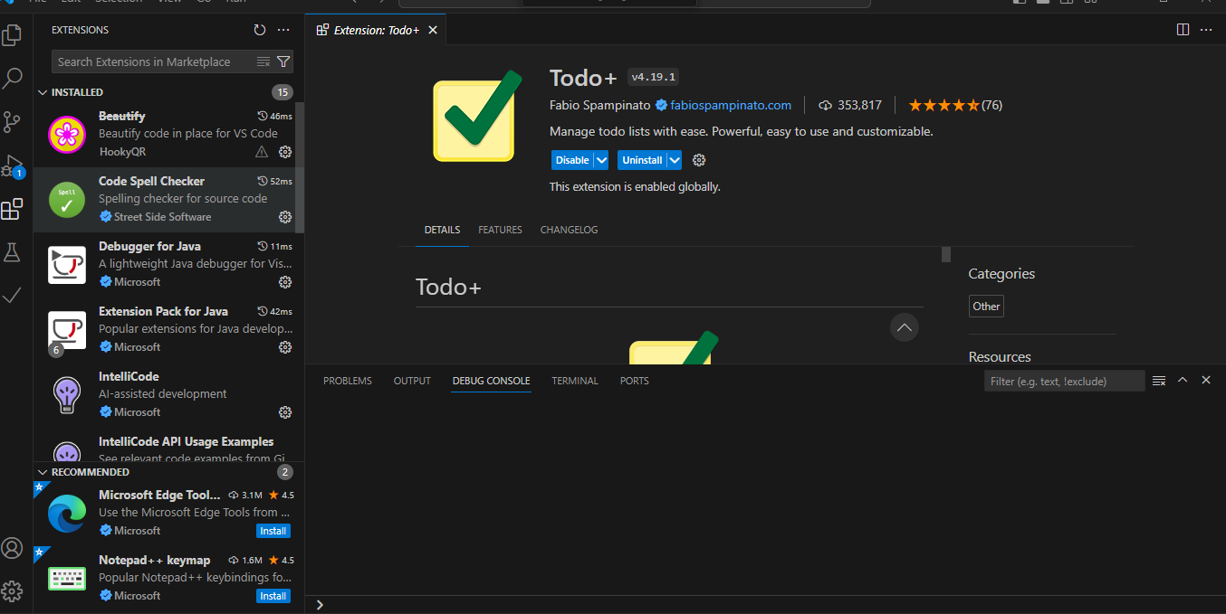

**Github:**

**Location: <https://github.com/sindhu1983/CIS-530-Server-Side-Development-Sindhu_gopal>**

